


Chalmers Memorial Church Newsletter
Christmas 2007



From the Minister:
“With the poor and mean and lowly lived on earth our Saviour holy”

These familiar words struck me as startlingly relevant when, of all things, I was listening to an interview with an MP on the radio. Before I say more about this, let me tell you what I have discovered about the hymn “Once in Royal David’s City” which came in at no.8 in a poll conducted by the BBC to find the nation’s favourite carols.

This hymn wasn’t originally intended as a Christmas carol at all. Rather was it one of fourteen hymns written by Dublin-born Sunday School teacher Mrs C.F.Alexander for her Hymns for Little Children which was published in 1848. These fourteen hymns were written to explain the different sections of the Apostles’ Creed, which we looked at phrase by phrase at our services at the start of this year. To take just three of the best-known hymns from the collection, Mrs Alexander wrote “All things bright and beautiful” to amplify the opening statement of the Creed: “I believe in God the Father Almighty, Maker of heaven and earth.” She wrote “There is a green hill far away” to unpack the full meaning of the phrase: “He was crucified, dead and buried.” She wrote “Once in Royal David’s city” to explain the statement: “I believe in Jesus Christ who was born of the Virgin Mary.” In marked contrast to hymns which seem to suggest that Jesus was totally other from the rest of us – think of the hymn which suggests “the little Lord Jesus, no crying he makes” – Mrs Alexander was at great pains to stress the full humanity of Jesus with her statement that “tears and smiles like us he knew.”

Although Mrs Alexander’s verses have been criticised and even sneered at for what seems a simplistic and at times mawkish view of the world, when we know that she was the daughter of a English army officer who took up the position as agent to the Earl of Wicklow and that she later married a clergyman who ended his career as Archbishop of Armagh and Primate of all Ireland, we can see that she knew what she was talking about when she wrote of the “rich man in his castle, the poor man at his gate.” When she wrote “When, like stars, his children crowned All in white shall wait around”, she was offering a comforting response to the appallingly high infant mortality rates prevailing in Victorian Britain at the time her hymn collection was published almost exactly 160 years ago. As the late Dr Erik Routley pointed out, she was always trying to answer the difficult and direct questions she was asked by the children in her care.

When we sing the three most popular of Mrs Alexander’s hymns (a fourth, “Jesus calls us o’er the tumult”, which we regularly sing at St Andrews-tide is not so popular forth of Scotland), we should perhaps stop and reflect on the wholly admirable purpose for which she wrote these hymns and the very challenging social divisions and conditions to which she was attempting to respond.

It was in response to the challenging times in which we now live that Mrs Alexander’s lines quoted above came to mind. There was a news item on the financial losses sustained by those families who had ordered Christmas hampers and gifts through Farepak, the company that went into liquidation shortly before last Christmas. The families who lost out have been asking how our Government can spend billions bailing out Northern Rock Building Society and yet hasn’t so far been able to find the relatively small sums required to assist those generally poor families who lost out through the collapse of Farepak. The Labour politician being interviewed was refreshingly blunt in her answer: “It’s because our society has a bias to the rich, not to the poor.”

When we sing Mrs Alexander’s words this Christmas, we may well reflect how some things change – our world, our celebration of Christmas, our use of language (which is why our new hymn book has changed ‘mean’ to ‘meek’) – yet, as our Government’s contrasting treatment of those who have lost money through no fault of their own demonstrates, what has not changed is the world’s need for Christ and for Christians who by their lifestyle give practical expression to His bias not to the rich but to the poor.

“With the poor and meek and lowly
lived on earth our Saviour holy”

MINISTER
Rev. Robert L Glover,
Braemar Villa, 2 Links Road, Port Seton
Tel: 812481
E-mail: rlglover@btinternet.com
(Please respect Monday
as the Minister’s day off)
Pastoral Cover
Rev Bill BROWN (0131 654 0929) will provide cover from Friday 30th November until Saturday 8th December.

EDITOR'S NOTE
Thanks to all who have contributed to this issue of the Church Newsletter.
The next issue will be available on
Sunday 27th January 2008
Articles for this edition should be with me by
Sunday 13th January 2008
If you would like to E-Mail news you can contact me on: chalmerschurch@btopenworld.com or by phone on 819471
Sheila Bulloch

The next meeting of the Candle Coffee Club will be on Thursday 20th December
Meeting at 10a.m. in Longniddry Inn.
This will be a Christmas Special
All Welcome



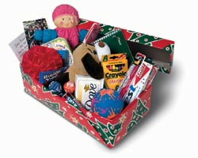
Shoeboxes
Thank you to everyone who donated to the Shoe Box Appeal. We collected 150 boxes. They are being sent to Belarus this year. If you can help at the warehouse, please see the poster in the Church Hall for opening times.

Thanks
Mrs Rita Jarron and family would like to thank everyone who attended the funeral service for her sister Ruby. Thanks also for the prayers, cards, letters and lovely flowers received. Mr Glover for your visits, help and prayers at this difficult time, we thank you.

Mary, Bill and Ina would like to thank everyone for their support, cards and flowers received on the death of their brother George and especially the Guild for serving a wonderful tea after the funeral. Thanks also to Rev Malcolm for the service and Rev Glover for his visits and prayers.

Thanks are expressed to all Hall Cleaners for their help in 2007 and hope they will continue the good work in 2008.

Sunday School and Youth News
It’s party time again! The annual Sunday School party will be held in the Church Hall on Saturday 22nd December from 2p.m – 4p.m. We invite all the Sunday School children from crèche up to P3 to join us for games, fun, food and perhaps a visit from someone dressed in red and white?!?

The older children P4 up to Rock Club will be taking part in their annual Megabowl Competition between Christmas and New Year; listen out for date and time.

Sunday 23rd December – The Christmas Presentation by Sunday School and Rock Club asks you ‘Have you heard the story?’

Funerals
26th Oct Thomas Alan DONALDSON
10 Wemyss Place
15th Nov Mrs Ruby CRAIG
Muirfield Nursing home, formerly Golf Drive
21st Nov George Edmund WHYTE,
99 North Seton Park
23rd Nov Anthony (Tony) HARRISON,
10 Links Place


HOME COMMUNIONS
Members who through illness or disability are unable to attend either of the forthcoming morning or evening communions and would like communion brought to them on the afternoon of Sunday 27th January 2008 are invited to speak to their Elder in the first instance.

Come and join the Festive Season
at Welcome Wednesday.
Wednesday 5th December 10-12noon
Christmas Coffee Time with mince pies (£1.50)
Home Baking will be on sale.
Wednesday 19th December
12 – 2pm Christmas Lunches
All Welcome

Publicity Co-ordinator
Mrs Irene Watson has been appointed as the Publicity Co-ordinator. If anyone has information they wish publicised via the local press etc. Please contact her on 811071 or by email - Irenemwatson@aol.com

We welcome contributions to the Church Newsletter. Please note however that these may be edited, summarised or omitted by the minister and editor, as circumstances require. Letters of general thanks and acknowledgement for Church flowers will be posted on the notice board in the Church Hall.

Christmas Thoughts and Prayers - Rejoice and be glad! The Redeemer has come!

Heavenly Father we thank you for the joys of this Christmas Season as we celebrate the birth of our Lord Jesus who came to earth to tell us of the wonderful love you have for each one of us. Forgive us that we have not always put you in the centre of every part of our lives. Help us at this Christmas time to rededicate ourselves in Your service. O come to us, abide with us, our Lord Immanuel. Amen.
As we look forward to all the Christmas services let us pray that as we meet together we may truly and sincerely worship the King of Kings and Lord of Lords, experience the presence of Jesus and praise and thank God for the wonderful gift of Jesus as our Saviour.
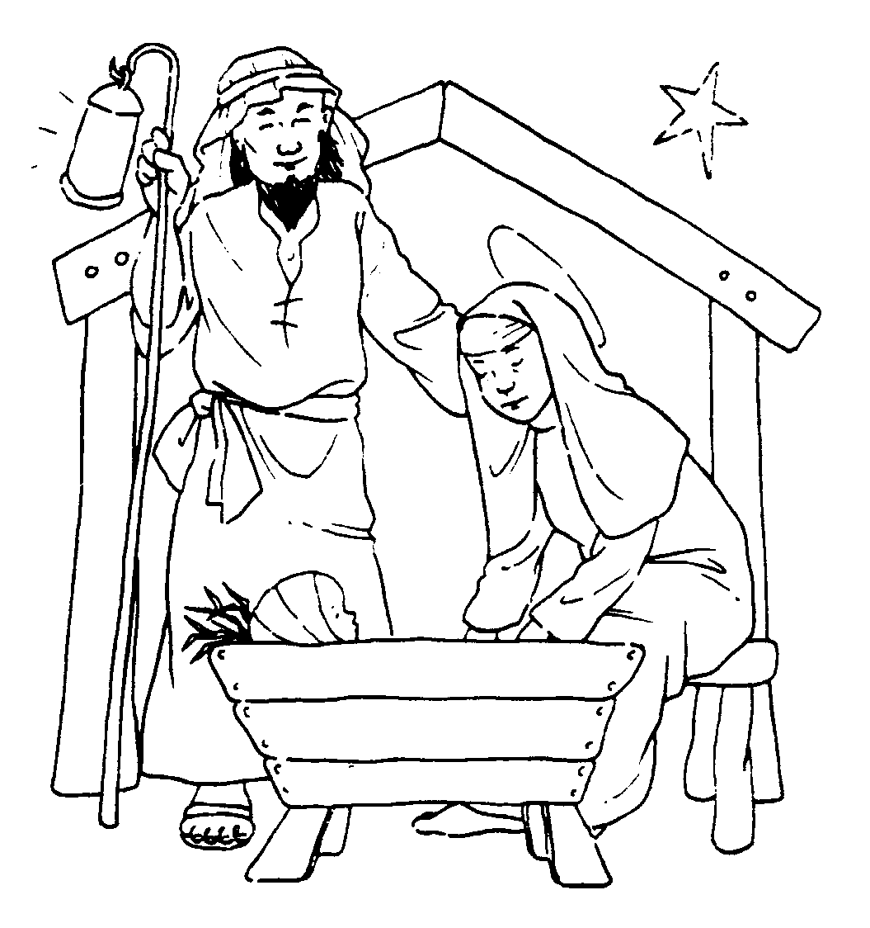
Let us pray that we like the innkeeper who had compassion on Mary and Joseph that first Christmas night might have compassion for the many in our own land and throughout the world that have nowhere to call home, who live in dire poverty and have no voice. Pray for all agencies that do their best to meet the needs in so many countries.

Remember all children especially in our own land who think that the purpose of Christmas is just to get toys and presents and do not know the real meaning of Christmas.
Pray that there may be a awaking in our land that once again men and women may come to know Jesus the”Wonderful Counsellor the Mighty God the Everlasting Father the Prince of Peace”.
At this time of year when we look forward with joy to being with family and friends let us not forget those in our community who are spending their first Christmas alone; folks who are worried about their health; those who are experiencing the break-up of relationships; young folks who find growing up difficult and are so easily led astray; old folks who are no longer able to live on their own and neighbours in our street who are going through difficult times. Bring them all to God asking that they may find comfort and peace at this time.

Let us thank God for all His faithfulness throughout 2007, both in times of blessing and of trial, in our personal lives and in our shared experience as a Church. Thank Him in anticipation for His goodness and mercy as it follows us throughout 2008 and in years to come.
Boys Brigade Christmas
Card Delivery Service

The post box for Christmas cards will be in the Church vestibule after all services. Cards will be collected from the box on 2nd, 9th and 16th December.
Each card costs 10p for deliveries within Cockenzie and Port Seton ONLY.

Congregational Christmas
Family Lunch
This will be served after
the Family Service on
Sunday 23rd December in the hall.
Tickets available in the Church Hall
from 9th December
£3adults
children free with an adult.

Christmas Services

Sunday 23rd December
11.00a.m. Family Service with presentation by the Sunday School and Rock Club. Followed by CONGREGATIONAL CHRISTMAS FAMILY LUNCH
5.00p.m. Carol Service at Cockenzie House
6.15p.m. Christmas Music with the Choir

Monday 24th December (Christmas Eve)
4.00 p.m. Family Carol Service
11.30 p.m. Watchnight Service
(Offerings for CHRISTIAN AID)

Tuesday 25th December (Christmas Day)
11.00a.m. Short Family Service
(Offerings for CHRISTIAN AID)

Sunday 30th December - Services for the Years End
11.00a.m. Morning Worship
6.15p.m. Evening Worship
With Rev. Bob GLOVER



MINISTER
Rev. Robert L Glover
Braemar Villa
2 Links Road
Port Seton
Tel: 812481
e-mail: rlglover@btinternet.com
(Please respect Monday
as the Minister’s day off)

Services and Meetings

Sunday
10:15 a.m. All-age Family Worship (in Hall)
Followed by Sunday School & Rock Club Groups
11.00 a.m. Morning Worship (with Crèche)
5:30 p.m. Choir Practice
6:15 p.m. Evening Worship - resumes 30th Sept.
7:30 p.m. Rock Solid Club (every 2nd week)

Monday
7:15 p.m. The Guild (Oct - March)

Tuesday
7.30 p.m. Emmaus
(Resumes in October)



Wednesday
Welcome Wednesday
10a.m – 12noon Coffee Time (1st)
12-2p.m. Chalmers Lunches (3rd)
10 - 11a.m. Prayer Time (last)
5:15 p.m. 1st Port Seton Rainbows (Sept. - June)
6:30 p.m. Boys Brigade –
Anchor boys and Junior Section
7:45 p.m. Company Section (Sept. - June)

Thursday
5:00 p.m. Rainbows}
6:30 p.m. Brownies } (Sept. - June)

Saturday
7.30 – 9a.m Prayer Breakfast (last of month)
6:30 – 7:45 p.m Youth Club for 8-10 yr olds
8.00 – 9:15 p.m Youth Club for 11yrs +
(Meets every 2nd week)

OUR WORSHIP – Special dates to note
Sunday 2nd December - First Sunday in Advent
10.15a.m., 11a.m. & 6.15p.m. Rev. Tom GORDON

Sunday 9th December - Second Sunday in Advent
10.15 a.m. All-age Worship - Amanda JOHNSTON
11.00 a.m. Traditional Worship - Duncan MORGAN
6.15 p.m. Evening Worship – Ian BULLOCH

Sunday 16th December - Third Sunday in Advent
10.15 a.m. All-age Worship
11.00 a.m. Traditional Worship both with Rev. Laurence TWADDLE Convenor of the Presbytery Visiting Team and Rev. Bob GLOVER
6.15 p.m. Evening Worship Rev. Bob GLOVER

Sunday 6th January 2008 - Services for Epiphany
11.00 a.m. Traditional Worship - Ian BULLOCH
6.15 p.m. Evening Worship –Duncan MORGAN
(Please note there will be NO 10.15a.m. service)

Sunday 13th January
10.15a.m., 11a.m. & 6.15p.m. Rev. Tom GORDON
Sunday School Classes resume today

Sunday 20th January
10.15a.m., 11a.m. & 6.15p.m. Rev. Bob GLOVER

Sunday 27th January
10.15 a.m. All-age Family Worship
with BAPTISM of Poppy HENDERSON
11.00 a.m. HOLY COMMUNION
5.00p.m. Short Service at Cockenzie House
6.15p.m. Evening Worship followed by
a brief celebration of HOLY COMMUNION
All with Rev Bob GLOVER

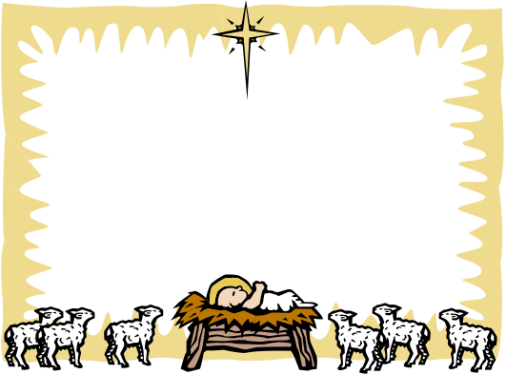
MINISTER SESSION CLERK CLERK TO DEACONS COURT
Rev. Robert L Glover Mr John Murdoch Mr Ian Bulloch
Tel: 812481 Tel: 812469 Tel: 852717
TREASURER ACCESS to the HALL contact BEADLE
Mrs Janet Farquhar Mr Tom Donaldson Mr Duncan Morgan
Tel: 811863 Tel: 812023 Tel: 812071
FLOWER CONVENER ORGANIST PRAYER SECRETARY
Miss Mary Clements Mrs Pamela Zenati Mrs Alice Hood
Tel: 812241 Tel: 813641 Tel: 812191
 Please recycle this newsletter and care for the earth as God intended
SC004630 Cockenzie and Port Seton: Chalmers Memorial Parish Church 'Scottish Charity'.

Services for the Christmas Season please see details on Page 3

